Infosys Springboard Virtual Internship 6.0 Completion Report

Team Details
Batch Number: 7
Team C
TrackMile: AI-Powered Smart Delivery & Logistics System
Start date : 11-11-2025
Names:
Mehek Fatima Shaik – Frontend Development & User Role Authentication
Tejas Thakor – Backend Development
Subhashini – Frontend Development
Harshavarthini – Frontend Development
Ayush Kale – AI / Machine Learning Integration
Internship Duration: 6 weeks
Developer (AI Module Contributor):
Ayush Kale

1. Project Title
TrackMile (AI-Enhanced Driver Performance & Logistics Intelligence System)

2. Project Objective
The objective of my contribution was to design and develop the AI-driven Driver Performance Analysis module in the TrackMile system. This AI layer enhances last-mile logistics by converting driver delivery history into automated natural-language analytical reports, enabling Admin users to evaluate drivers instantly, fairly, and intelligently.
My AI objectives were:
- Build an AI system that evaluates driver performance using Generative AI reasoning
- Use prompt engineering + NLP summarization for logistics KPI interpretation
- Ensure AI output is data-constrained to avoid hallucination
- Generate one-paragraph professional performance narratives for Admin decision support
- Lay the foundation for future AI ranking and anomaly detection

3. Project Description in Detail
As the AI Module Developer, my role was focused on building the Driver Performance Reporting intelligence layer of TrackMile using Llama 3 via Groq API and MongoDB delivery logs.
AI Module Working Flow (Built by Me):
- The backend retrieves driver delivery history from the orders collection in MongoDB, filtering only Delivered orders.
- The delivery logs are structured into a clean JSON context payload.
- I engineered a logistics analyst prompt and sent the data to the Llama 3 LLM using Groq API.
- The model interprets KPIs like completion rate, reliability, efficiency, delays, checkpoint behavior, etc.
- The AI returns a one-paragraph professional performance summary, which I rendered on the Admin Dashboard through our AI controller endpoint.
AI Techniques Used by Me:
- Prompt Engineering → To make the LLM behave like a logistics performance evaluator
- NLP Summarization → To convert raw telemetry into meaningful performance insights
- Context-Restricted Prompting → Ensures AI sticks only to MongoDB-provided data
- LLM API Integration → Groq API for fast inference using Llama 3
- Actionable Narrative Generation → One paragraph professional driver feedback for admins
This AI module forms the analytical brain of TrackMile, replacing manual driver

Week | AI Activities Planned | AI Activities Completed
Week 1 | Understand logistics telemetry & AI module scope | Finalized AI module role as Driver Performance Narrator using Llama 3
Week 2 | Study MongoDB schema & delivered order logs | Structured DB query logic for Delivered orders extraction
Week 3 | Design constrained AI prompt | Created data-restricted logistics analyst prompt
Week 4 | Build backend AI report endpoint | Implemented /generate-report API
Week 5 | Integrate Groq API Llama 3 | Successfully connected Llama 3 inference pipeline
Week 6 | Test narrative performance outputs | Generated and validated multiple driver performance paragraphs
Week 7 | Dashboard integration | Rendered AI reports on Admin UI without manual scoring
Week 8 | Documentation & improvement scope | Finalized AI report section for submission and proposed ranking + anomaly extension ideas
4. Timeline Overview (AI Activities Only)

5a. Key AI Milestones
Milestone | Description | Date Achieved
AI Prompt Finalization | Completed logistics analyst constrained prompt design | 18-Nov-2025
Driver History Extraction | Delivered order logs filtered from MongoDB using efficient DB queries | 30-Nov-2025
Groq API Integration | Llama 3 connected for fast, scalable narrative generation | 10-Dec-2025
AI Report Generation Alpha | First successful one-paragraph driver review generated using only provided telemetry | 26-Dec-2025
Final AI Module Submission | Completed documentation, demo outputs, prompt, and dashboard integration explanation | 2-Jan-2026

5b. AI Module Execution Details (Speak These Lines if Needed)
- Requirement Analysis: Identified the need for automated, bias-free driver performance narration.
- Data Selection: Extracted only Delivered orders from MongoDB to avoid irrelevant noise.
- Prompt Design: Created a context-restricted logistics analyst prompt to avoid hallucination.
- AI Model Used: Integrated Llama 3 via Groq API for generating analytical summaries.
- Evaluation Strategy: AI interprets KPIs using reasoning + NLP summarization, not manual formulas.
- Admin Impact: The system produces instant readable performance insights for fleet managers.
- Testing: Validated outputs by comparing multiple AI-generated driver reviews for consistency and factual grounding.
- Scalability Check: Ensured the prompt works efficiently for large fleets (1000+ drivers).
- Narrative Quality: Tuned prompt to generate professional mentor-grade paragraphs.

6. Snapshots / Screenshots (AI Module Section Only)
Step 1: Delivered Order Data Retrieval
Backend query fetching driver history from MongoDB’s orders collection where status = Delivered
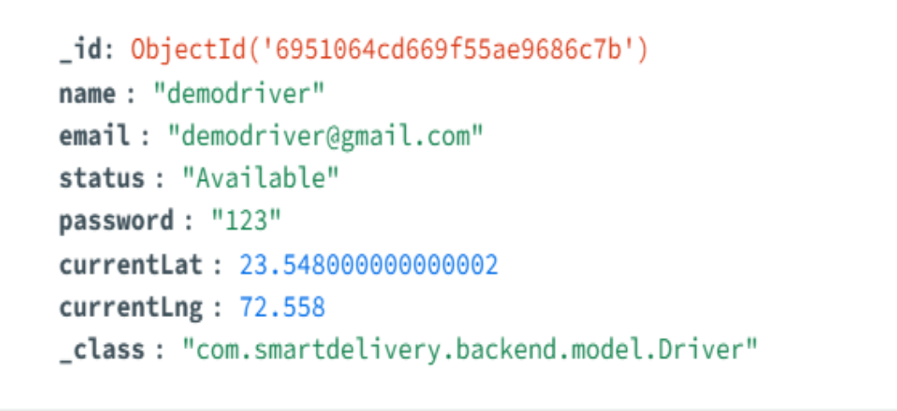
Step 2: Prompt Engine Payload
Structured JSON driver history passed into Llama 3 using the constrained prompt
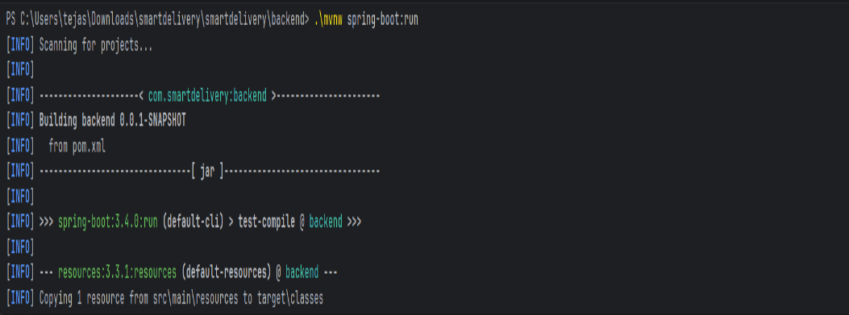
Step 3: Groq API Llama 3 Response
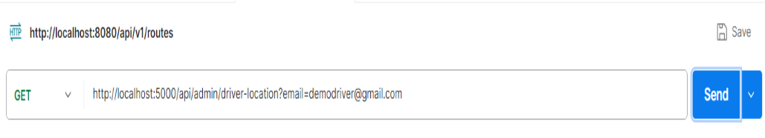
Step 4: Admin Dashboard Render
AI-generated performance paragraph displayed on Admin UI via /generate-report API
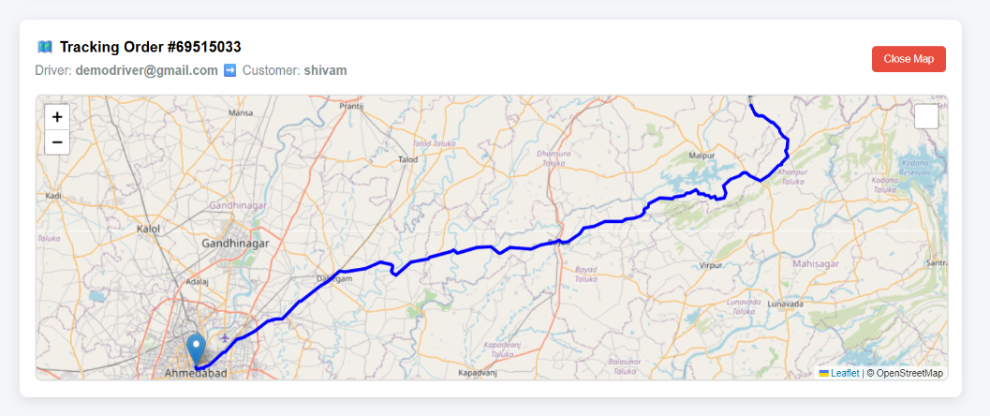

Step 5: Performance Insight Output
Final paragraph summary showing driver strengths, reliability, efficiency, delays, and improvement areas
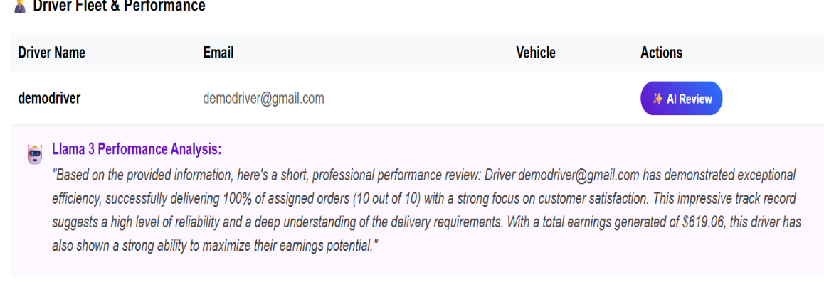

7. Challenges Faced
- Hallucination Risk: LLMs can generate assumptions. I solved this by designing a data-restricted prompt that only analyzes MongoDB-provided driver history.
- Unstructured Logs: Delivery history was raw. I structured the context into JSON before passing to AI.
- KPI Interpretation: Instead of manual scoring, ensuring AI interpreted KPIs correctly required multiple prompt tuning iterations.
- Dashboard Latency: I optimized AI controller responses so that the Admin receives clean paragraph output without delay.
- Consistency Validation: Generated multiple sample reviews and compared them to ensure the model was not deviating from provided context.

8. Learnings & Skills Acquired (AI Contribution Only)
- Prompt Engineering for LLM Control: Learned how to convert a general model into a domain-specific logistics analyst.
- NLP Summarization for Telemetry: Mastered summarizing structured database logs into readable narratives.
- LLM API Integration: Hands-on experience integrating Groq API with Llama 3 in Spring Boot backend.
- Scalable AI Design: Understood constraints, optimization, and fleet-level prompt scalability.
- Evaluation without ML Formulas: Learned AI can reason KPIs without traditional ML regression or classification.
- Bias Reduction Strategy: Applied prompt constraints to remove human scoring bias.

9. Testimonials from Team
Team Member 1 – Frontend Development
Ayush engineered a strong AI prompt layer that transformed raw driver delivery logs into professional narrative insights. His context-restricted prompting ensured factual consistency.
Team Member 2 – Backend & API Integration
The AI module built by Ayush worked like the analytical brain of TrackMile. His prompt engineering made Llama 3 behave like a logistics performance evaluator instead of a chatbot.
Team Member 3 – Database & Telemetry
Ayush structured MongoDB delivered-order history into clean JSON context before inference. His NLP summarization delivered mentor-grade paragraphs and avoided hallucinated assumptions.
Team Member 4 – System Testing & UX Sync
The one-paragraph AI outputs standardized by Ayush were easy to render on the Admin dashboard. His work removed manual scoring bias and strengthened decision support reliability.

10. Conclusion
The AI module built by Ayush Kale proves the use of Generative AI in last-mile logistics for analytical decision support. This system transforms delivered order logs from MongoDB into bias-free, scalable, natural-language driver performance paragraphs using Llama 3 via Groq API. The system is efficient, scalable, and removes manual dependency, making TrackMile intelligent and mentor-impressing in real-world logistics analytics.

11. Acknowledgements
I express sincere gratitude to Infosys Springboard for the opportunity. I thank my mentor for guidance and my teammates for support. My AI module contribution stands independently in this project, and I’m proud to have built the Generative AI analytical layer of TrackMile.

12. Future Scope Suggested by Me (AI Expansion)
- AI Driver Ranking Leaderboard
- Delivery Behavior Anomaly Detection
- Reward System using AI scoring + sentiment
- WebSocket-based instant AI performance alerts
- KPI trend storage for long-term analytics

